The CEO’s Remarks
The movement of the exchange rate has caused concern and discussion within the society. Historically, whenever there is a depreciation of the Jamaican dollar, businesses tend to increase the price of goods and services and so consumers come to expect that prices will automatically increase whenever the Jamaican dollar depreciates. However, it is noted that not all businesses increase prices when the Jamaica dollar devalues as it is recognized that consumers’ spending power is limited and that there is competition in the market place as well as the elasticity of demand for some products.
The discussion on the need to target inflation therefore becomes a more difficult topic to introduce when the Jamaican dollar is depreciating. So, the fluctuations in the exchange rate will be carefully monitored. Our Annual Economic Forum to be held on September 20, 2018 will provide an opportunity to discuss these and other matters.
The recent announcements by the Minister of Finance and the Public Service on the formation of a Fiscal Council as well as the acceptance of the recommendations on a Competency Profile for boards of public bodies are indeed welcomed. The PSOJ’s Corporate Governance Committee had done considerable work to develop a Competency Profile and is it hoped that our recommendations will eventually become the Regulations for membership to these boards.
The Special Zones Authority (SEZ) has been formed and the Regulations will be promulgated soon. The SEZ incorporates the Free Zones and will also create new zones. It is expected that these zones will create significant economic activity in their communities as well as wider geographical areas.
In order for the SEZ’s to perform well on the international stage though, the country needs to improve on productivity. Labour productivity is low and the educational and training institutions need to be delivering candidates at a significantly higher level of skill sets. The procurement / recruitment of labour requires more resources to be expended in developing the employees that are most suitable for the job. If this is not improved, then the benefits of the SEZs will not significantly redound to Jamaicans.
Finally, as an island economy, Jamaica is subject to the vagaries of the weather and climate change. The need to build climate resilience is a matter that requires attention and the PSOJ has engaged with a number of international agencies with a view to creating awareness of this need and the need to build capacity to manage it.

Economic Highlights: July 2018
At the end of July 2018, the monthly average value of the Jamaican Dollar depreciated against all three major trading currencies. The Jamaican Dollar depreciated against the US$ by J$1.49 to end at J$132.25 =US$1.00. The Dollar depreciated by J$3.15 or 3.0% against the Canadian Dollar to end at J$103.39 = CAD$1.00. The value of the Jamaican Dollar depreciated by J$0.26 against the British Pound to end at J$174.62 = GBP£1.00.
Inflation, measured by the All Jamaica “All Divisions” Consumer Price Index (CPI) for the period July 2018 over June 2018 showed that prices increased by 1.0% according to the July 2018 Consumer Price Index (CPI) Bulletin. The calendar year-to-date movement was 0.7%, the point-to-point movement was 3.2 %, and the fiscal year-to-date movement was 1.0 %.
As at the end of July 2018 the stock of Net International Reserves (NIR) at the Bank of Jamaica was J$416.52 billion (US$3,149.48 million). The monetary base increased by J$5.6 billion to end the month of July at J$175.4 billion.
For the month of July 2018 yields on the Government of Jamaica 91-day and 182-day treasury bills were 1.96% and 2.07% respectively.
Stopover tourist arrivals for June 2018 were 229,261. For the calendar year-to-date, arrivals increased by 6.0%, with 1,254,488 stopovers compared to 1,118,753 in 2017. A total of 92,323 cruise passengers visited Jamaica in June 2018. Cruise passengers visiting the port of Ocho Rios grew by 4.3% with 32,224 passengers and visits to the port of Montego Bay grew by 24.2 % (29,77 passengers).
The price of Dated Brent fell while the West Texas Intermediate (WTI) increased for the period July 2018 relative to June 2018. The Brent decreased by 0.2% while the WTI increased by 4.6%. Natural gas prices decreased by approximately 5% in July 2018 relative to June 2018.

International Commodity Prices

Crude Oil Prices
For the month ending July 2018, the average price of the Dated Brent decreased while the average price of the West Texas Intermediate (WTI) increased (Figures 1 and 2). The Dated Brent ended the month of July at US$74.25 per bbl. This represented a US$.16 or 0.22% decrease relative to the US$74.41 per bbl recorded for June 2018. The WTI ended the month at US$70.98. This represented a US$3.11 or 4.58% increase relative to June 2018. A one-year comparison of prices revealed that the July 2018 prices for the Brent and WTI were US $25.56 per bbl (5.25%) and US$24.33 per bbl (5.22%) higher that the July 2017 prices. A two-year comparison of prices revealed that the July 2018 prices for both the Brent and WTI increased relative to July 2016 prices. The Dated Brent price increased in excess of 5.72% while the WTI increased in excess of 5.88%. The five-year average of prices from July 2013 to June 2018 for the Dated Brent and the West Texas Intermediate were US$67.88 per bbl and US$63.89 per bbl respectively, indicating that the July 2018 prices were US$6.37 per bbl (9.38%) and US$7.09 per bbl (11.09%) higher than the five-year average of prices for the Brent and the WTI respectively.
In July 2018, the US Energy Information Administration (EIA) in its Short-Term Energy Outlook (STEO) forecasts that Brent crude oil spot prices averaged $74 per barrel (b); largely unchanged from the average in June. EIA expects that Brent spot prices will average $72/b in 2018 and $71/b in 2019 and that West Texas Intermediate (WTI) crude oil prices will average about $6/b lower than Brent prices in 2018 and in 2019.
Figure 1: Crude Oil Prices, July 2017-July 2018

Figure 2: Crude Oil Prices, July 2013-July 2018

Natural Gas
For the month ending July 2018, natural gas price decreased (Figures 3 and 4). The price for natural gas ended at US$2.93 per million metric, which represented a decrease of US$0.10 or 3.41% over June 2018 price. In July 2017, natural gas per million metric was valued at US$2.96, signaling a US$0.03 increase over the corresponding period in 2018. A two-year comparison revealed that the natural gas price increased by US$0.04 per million metric or 1.4%. The five-year monthly average price for natural gas from July 2013 to June 2018 was US$3.15 per million metric indicating that July 2018 May price is US$0.32 (10.2%) below its average.
In July, the EIA forecasts that U.S. dry natural gas production will average 81.1billion cubic feet per day (Bcf/d) in 2018, up by 7.5 Bcf/d from 2017 and establishing a new record high. EIA expects natural gas production will rise again in 2019 to 84.1 Bcf/d. LNG exports averaged 1.9 Bcf/d in 2017. The EIA expects Henry Hub natural gas spot prices to average $2.96/million British thermal units (MMBtu) in 2018 and $3.10/MMBtu in 2019.

Figure 3: Natural Gas Prices, July 2017-July 2018

Figure 4: Natural Gas Prices, July 2013-July 2018

Soybean Prices
In May 2018, the average prices of soybean meal and soybean oil decreased (Figures 5 and 6). Soybean prices ended the month of May 2018 at US$431.00 per metric ton was; US$11.00 or 2.49% decrease from April’s value of US$442.00 per metric ton. Soybean meal prices ended the month at US$465.00 which was a US$8.00 or 1.69% decrease relative to April 2018. At the end of May, the price per metric ton for soybean oil stood at US$793.00 per metric ton, representing a US$34.00 or 4.11% decrease compared to the previous month. A one-year comparison revealed that prices for soybean increased by 11.08% or US$43.00. For the month of May 2018, soybean price was US$49.00 or 12.47% higher than its price in May 2016. When compared to the corresponding period in May 2017 the soybean meal price was US$115.00 or 32.86% higher. Soybean oil price was below last year’s price by US$34.00 or 4.11%. A two-year comparison of prices for soybean meal revealed that this year’s price is above prices two years ago by US$31.00 or 7.14%. When the May 2018 soybean oil price was compared to the corresponding period in 2016, the 2018 price is US$2.00 or 0.25% higher. The five-year monthly average price for soybean from May 2013 to April 2018 is US$437.09 per metric ton, indicating that April’s price was US$6.09 or 1.39% higher. The five-year average monthly price for soybean meal ranging from May 2013 to April 2018 is US$435.66 per metric ton, suggesting that May’s price was US$29.34 or 6.73% higher. The five-year monthly average price for soybean oil ranging from May 2013 to April 2018 is US$855.37 per metric ton, which means that May’s price was US$62.37or 7.29% lower.
Figure 5: Monthly Soybean Prices, May 2017-May 2018
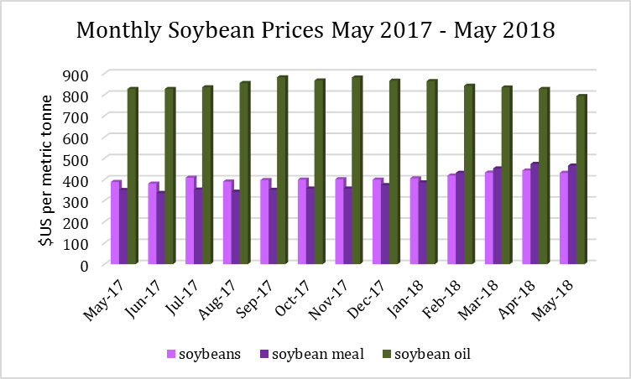

Figure 6: Monthly Soybean Prices, May 2013-May 2018
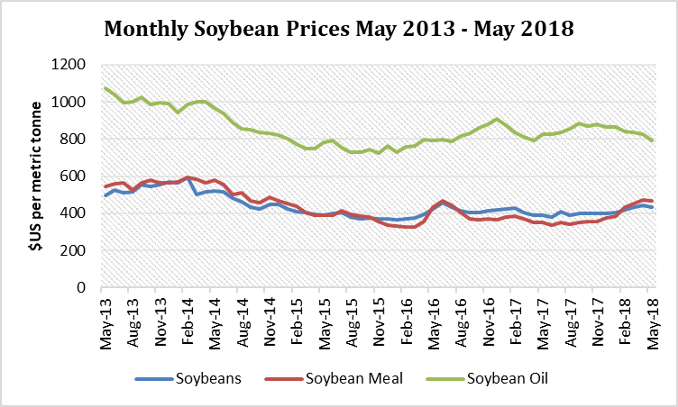

Sugar Prices
At the end of May 2018, the average price of the Free Market Sugar ended the month at US$0.27per kg, which was the same relative to last month (Figure 7). For the US Sugar imports, the average price was US$0.54 per kg, representing a US$0.01 or 1.82% decrease over last month. At the end of May 2018, the European Sugar imports ended the month at US$0.39 per kg. This was US$0.01 or 2.50% less than last month. For the period May 2018 relative to May 2017, the price of Free Market sugar decreased by US$0.08 or 22.86% dollar per kg. A one-year comparison revealed that the price of the US Sugar imports has decreased by US$0.09 or 14.28%, while the European sugar imports price has increased by US$0.03 or 8.33%for the same period (Figure 8). In May 2016, the price for the Free Market sugar was US$0.38 per kg, representing a decrease of US$0.11 or 20.94%. The price of the US sugar imports is US$0.06 or 10.00% lower than the 2016 price while the price of the European Sugar imports is US$0.02 or 5.40% higher than the 2016 price (Figure 8). The 5-year average of prices ranging from May 2013 to April 2018 for the US imports and the European imports are US$0.56 per kg and US$0.39 per kg respectively. Hence, the price of US imports is above its long-term average by 3.1%while the European imports is same as its average.

Figure 7: Monthly Sugar Prices, May 2017-May 2018
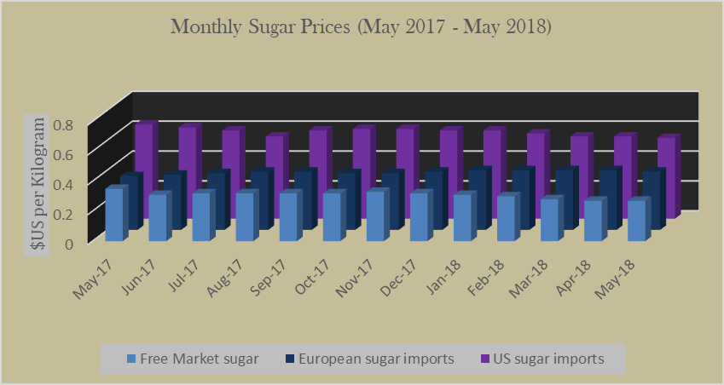

Figure 5: Monthly Sugar Prices, May 2013-May 2018
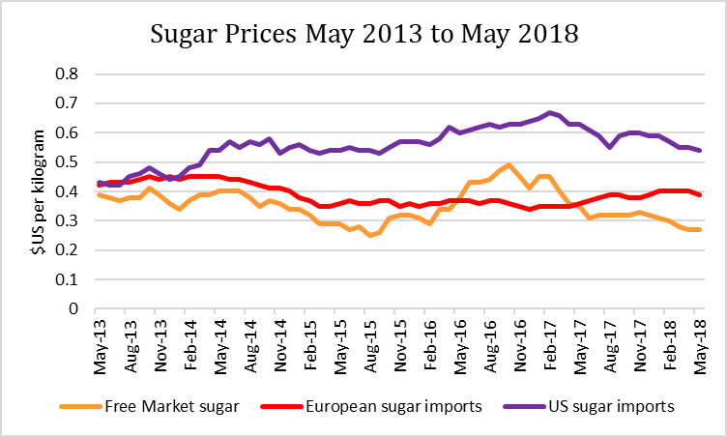

Coffee
For the month ending July 2018 price for the Other Mild Arabica’s category decreased (Figure 9 and 10). The price per kg for coffee of the Other Mild Arabica’s category was US$2.87 per kg, representing a decrease of US$0.16 (5.28 %) when compared with June 2018 price. A one-year comparison revealed that the July’s 2018 price was US$0.43 lower than price recorded in July 2017 and US$0.92 lower than in 2016. Robusta Coffee ended the month of July at US$1.86 per kg, US$0.08 below the price recorded in June 2018. Price comparison statistics revealed that the price of coffee in the Robusta category decreased by US$0.45 when compared with the July 2017 data and US$0.14 in comparison to July 2016 price. The five-year monthly average prices ranging from July 2013 to June 2018 for Arabica and Robusta were US$3.57 and US$2.06, respectively. This implies that this year’s July prices for both the Arabica and Robusta coffee were 19.5% and 5.6% lower than their average prices.

Figure 9: Monthly Coffee Prices, July 2017-July 2018

Figure 10: Monthly Coffee Prices, July 2013-July 2018

Cocoa Beans
For the month ending July 2018, cocoa bean prices decreased relative to the previous month (Figure 11 and 12). The price of cocoa beans averaged US$2.36 per kg, representing a US$0.05 (2.07%) decrease relative to June 2018. A one-year comparison revealed that July’s 2018 price was higher by US$0.37 per kg in July 2017, whereas the two-year price comparative statistics showed that the July 2018 price for cocoa beans was lower by US$0.69 per kg than it did in July 2016. The five-year average of monthly prices ranging from July 2013 to June 2018 for cocoa bean was US$2.72 per kg; US$0.36 higher than the July 2018 price.
Figure 11: Monthly Cocoa Bean Prices, July 2017-July 2018

Figure 12: Monthly Cocoa Bean Prices, July 2013-July 2018

Banana Prices
For the month ending May 2018, banana prices ended at US$1.15 per kg which was $US0.01 or 0.86% lower than the previous month (Figure 13 and 14). When compared to the same period in 2017, this year’s price was US$0.06 or 5.50% higher. A two-year comparison revealed that prices in 2018 have risen by US$0.16 or 16.16. The five-year monthly average price ranging from May 2013 to April 2018 is US$1.00, indicating that this month’s price was US$0.15 or 15.47%higher.

Oranges Prices
Orange prices for the month ending May 2018 increased relative to April 2018 (Figure 13 and 14). In this regard, prices increased by 15.79% or US$0.12 to end at US$0.88 per kg. For May 2018 relative to May 2017, oranges prices decreased by US$0.12 or 15.79% per metric ton. A two-year comparison revealed that May 2018 price is US$0.12 or 15.79% higher than the April 2016 price. The five-year monthly average prices from May 2013 to April 2018 is US$0.81, this means that this year’s price was US$0.06 or 8.05% lower.
Figure 13: Monthly Banana and Orange Prices, May 2017-May 2018
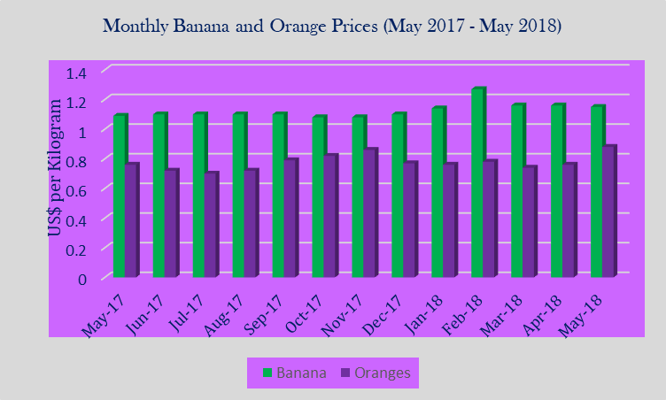

Figure 14: Monthly Banana and Orange Prices, May 2013-May 2018
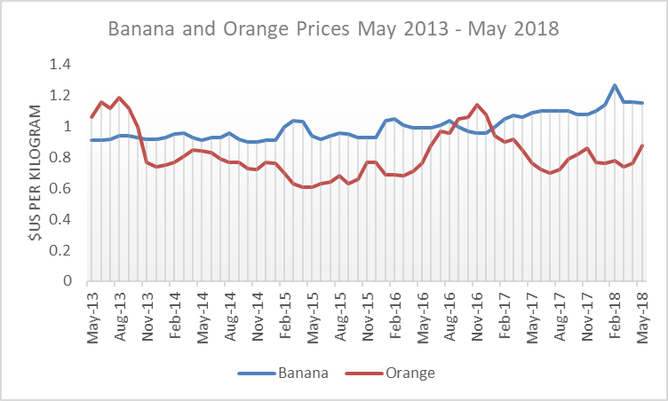

Beef Prices
In May 2018, beef prices decreased relative to the previous month. Prices decreased by US$0.06 per kg or 1.43% when compared to the previous month, to close at US$4.15 per kg (Figure 15 and 16). When compared to May 2017, prices have decreased by US$0.27 or 6.11% per kg. In May 2016 prices were US$3.96 cents per pound hence this year’s price was US$0.19 or 4.80% above the 2016 price. The five-year average for prices ranging from May 2013 to April 2018 is US$4.32 cents per pound indicating that May 2018 price was US$0.17 or 3.89% lower.

Chicken (Poultry)
Chicken prices were US$2.62 per kg at the end of May 2018 (Figure 15 and 16). This was approximately US$0.27 or 11.49% higher relative to the April 2018 price. A one-year comparison showed that April 2018 price was US$0.29 or 12.45% higher relative to May 2017 price. In May 2016, the price for poultry was US$2.06 per kg, indicating that this year’s price was US$0.56 or 27.18% higher. The monthly average price ranging April 2013 to May 2018 is US$2.08 cents per pound, this means that May 2018 price was US$0.54 or 25.96% more.

Figure 15: Monthly Beef and Chicken Prices, May 2017-May 2018
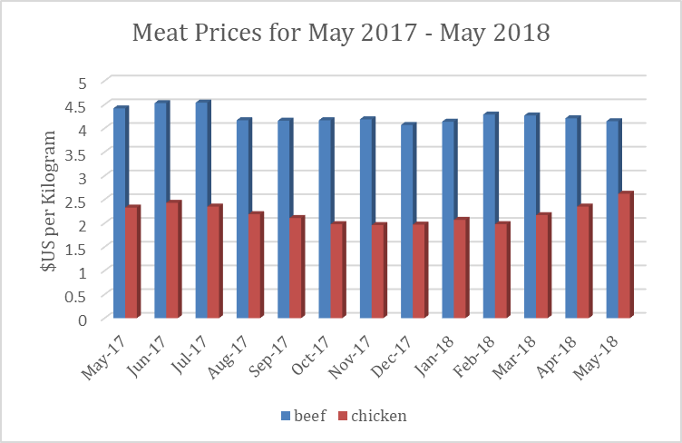
Figure 16: Monthly Beef and Chicken Prices, May 2013-May 2018
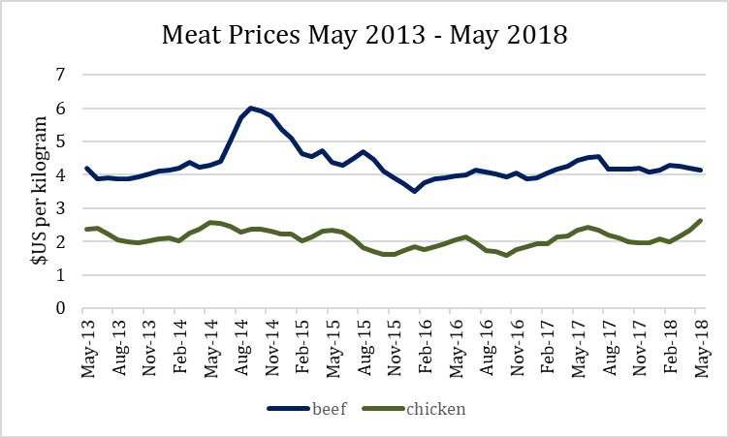
Rice
For the month ending July 2018 the price of the Thailand 5 % rice ended at US$398.00 per metric ton, a decrease of US$33 (7.7%) per metric ton (Figure 17). The June 2018 price is below the May 2017 price by US$19.00 or 5%. A two-year comparison revealed that the commodity’s price was US$44.00 or 10% lower than its price in 2016. The five-year monthly average price for rice from July 2013 to June 2018 was US$412.24 per metric ton, indicating that July’s price was US$14.24 or 4% lower than the long-term average.

Figure 17: Monthly Cereal Price-Rice, July 2017-July 2018

Maize (Corn)
For the month ending May 2018, corn prices increased (Figure 18). Prices increased by US$3.49 or 1.99% relative to April, to close the month at US$179.09 per metric ton. Between May 2017 and May 2018 prices increased by US$20.5 or 12.92%. A two-year price comparison showed that 2018 price was US$10.13 or 5.99% higher. The five-year monthly average for corn prices ranging from May 2013 to March 2018 is US$176.35 per metric ton, this means that this month’s price was US$2.73 or 1.55% lower.

Figure 18: Monthly Cereal Price-Maize (Corn), May 2017-May 2018
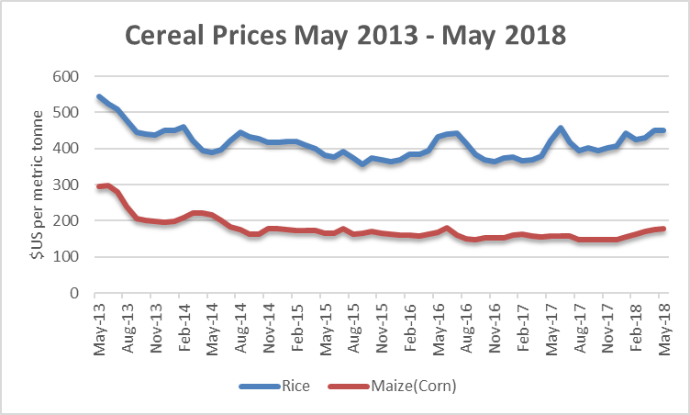
Aluminum
The price of aluminum increased in May 2018 relative to April (Figure 19 and 20). Prices increased by US$44.98 or 1.99% to end the month at US$2,299.67 per metric ton. For May 2018 relative to May 2017, prices increased by US$386.65 or 20.21% per metric ton. A two-year comparison revealed that this year’s price was US$749.04 or 48.30% above the price for the corresponding period in 2016. The five-year for monthly average prices ranging from May 2013 to April 2018 for aluminum is US$1,803.87 per metric ton, this means that May 2018 price was US$495.80 or 27.48% higher.

Figure 19: Monthly Aluminum Prices, May 2017-2018
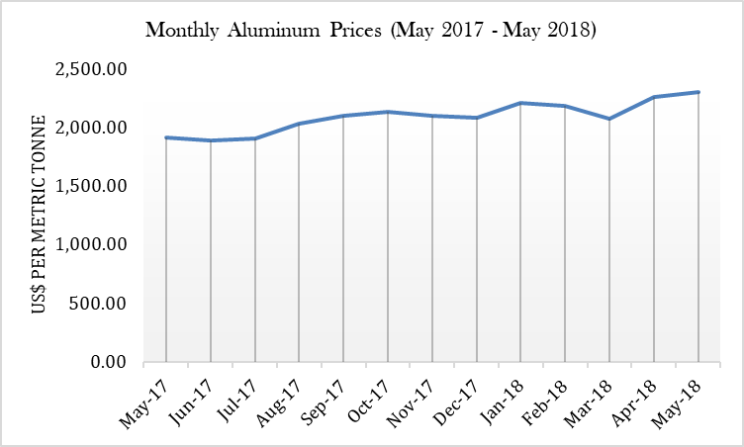

Figure 20: Monthly Aluminum Prices, May 2013-2018
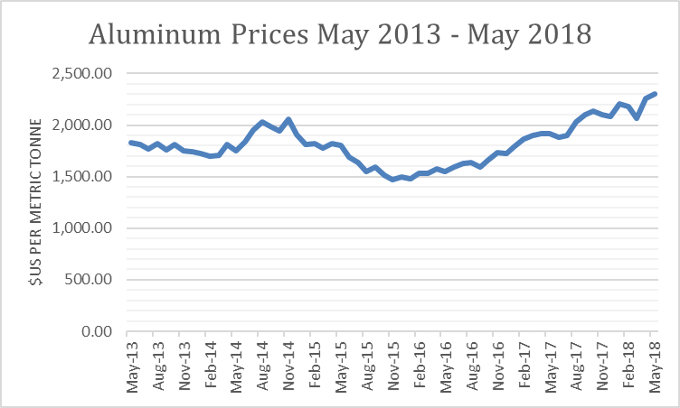
Impact of International Prices-July 2018
Price reductions were observed in 6 of the 7 commodities monitored for the July 2018 period. The price of Brent decreased while the West Texas Intermediate (WTI) increased. The Brent decreased by 0.22% and the WTI increased by 4.58%. Natural gas prices decreased in July 2018 relative to June 2018 (Table 2).
The Food and Agriculture Organization of the United Nations (FAO) Food Price Index (FFPI) averaged 168.8 points in July 2018, down 6.5 points (3.72%) from June level and 10.3 points (3.7 %) from the corresponding period in 2017. The FAO Cereal Price Index averaged 160.9 points in July 2018, down almost 6 points (3.6%) from June 2018 and 1.3 points (0.8%) below its level recorded at July 2017. The decline observed in July was driven primarily by weaker exports quotations for wheat, maize (corn) and rice. The FAO Sugar Price Index was 166.7 points in July 2018, down 10.7 points (6.0 %) from June 2018 and nearly 20 per cent lower than its level recorded in June 2017. This sharp decline in July was largely driven by improved production prospects in the main sugar producing countries: India and Thailand. The FAO Meat Price Index averaged 170.7 points in July 2018, down 3.3 points (1.9%) from its revised value in June 2017. The June upward revision was reflective of a rise in bovine meat prices in Brazil. This was as a result of a decline in exports due to logistical problems. FAO Dairy Price Index averaged 199.1 points in July 2018, down 14.1 points (6.6 percent) from June 2018. At this level, the index stood at 10.7 percent above January 2018 but still 8 % below the corresponding in 2017. The FAO vegetable Oil Price Index was 141.9 points in July, down 4.2 points (2.9%) from June 2018, marking a sixth consecutive fall and a two-and-a-half year low. This latest slide mostly reflects weakening values of palm oil and soy oil.

Table 2: Summary of international Commodities monitored in July 2018

Commodity | Unit | June 2018 Price | July 2018 Prices | Monthly Change %
Cocoa Beans | Metric tonne | 2.41 | 2.36 | -2.07%
Coffee-Arabicas | Kilogram | 3.03 | 2.87 | -5.28%
Coffee-Robusta | Kilogram | 1.94 | 1.86 | -4.12%
Natural gas | MMBTU | 2.93 | 2.83 | -3.41%
Crude Brent | Barrel | 74.41 | 74.25 | -0.22%
Crude West Texas Intermediate | Barrel | 67.87 | 70.98 | 4.58%
Rice | Metric tonne | 431.00 | 398.00 | -7.66%

Monthly Inflation Rate and Treasury Bill Rates

Monthly Inflation Rate

Inflation, measured by the All Jamaica “All Divisions” Consumer Price Index (CPI) for the period July 2018 was 250.4, indicating an inflation rate of 1.0 per cent. According to the CPI bulletin (July 2018), this movement was influenced mainly by the 3.4 per cent rise in index for the division ‘Housing, Water, Electricity, Gas and Other Fuels’. Within this division, the two groups ’Electricity, Gas and other Fuels’ and ’Water Supply and Miscellaneous Services Related to the Dwelling’, registered increases of 5.8 per cent and 1.6 per cent respectively. For July 2018, the calendar year-to-date movement was 0.7 per cent, the point-to-point 3.2 per cent, while the fiscal year-to-date movement was 1.0 per cent.
Seven of the twelve groups recorded decreases for the July 2018 period. One group recorded an increase in its index while the remaining three groups have no movements in their indices (Table 1).
Table 1: All Jamaica ‘All Divisions’ and Division Indices and Movements (Base period December 2006 = 100)
Divisions, Groups and  Classes | July 2018 Index | June 2018 Index | Past Month | Year To Date | Point To Point | Fiscal Year 18/19
All Divisions - All Items | 250.4 | 248.0 | 1.0 | 0.7 | 3.2 | 1.0
01-Food and Non-Alcoholic Beverages | 311.5 | 308.7 | 0.9 | -0.7 | 2.6 | 1.1
02-Alcoholic Beverages and Tobacco | 313.1 | 313.0 | 0.0 | 0.7 | 2.6 | 0.2
03-Clothing and Footwear | 242.8 | 242.4 | 0.2 | 1.1 | 2.5 | 0.7
04-Housing, Water, Electricity, Gas and  Other Fuels | 247.9 | 239.7 | 3.4 | 3.7 | 8.0 | 0.4
05-Furnishings, Household Equipment  and Routine Household Maintenance | 239.3 | 238.8 | 0.2 | 1.1 | 1.9 | 0.7
06-Health | 149.0 | 148.8 | 0.1 | 0.9 | 1.7 | 0.8
07-Transport | 215.2 | 213.4 | 0.8 | 2.5 | 3.5 | 2.5
08-Communication | 67.1 | 67.1 | 0.0 | 0.0 | 0.3 | 0.0
09-Recreation and Culture | 194.1 | 193.9 | 0.1 | 1.0 | 2.7 | 0.7
10-Education | 195.4 | 195.4 | 0.0 | 0.5 | 2.7 | 0.0
11-Restaurants and Accommodation  Services | 197.5 | 197.1 | 0.2 | 0.7 | 1.9 | 0.5
12-Miscellaneous Goods and Services | 236.1 | 235.8 | 0.1 | 1.6 | 2.3 | 0.5
Source: Statin, 2018. Consumer Price Index-Bulletin, July 2018

Government treasury bills
For the month of July 2018 yields on the Government of Jamaica 91-day and 182-day treasury bills were 1.96% and 2.07%, respectively. For July relative to June yields on both the 91-day and 182-day bills decreased by 58bps and 59bps respectively. For the period July 2018 in comparison to July 2017, yields on GOJ 91-day and182-day decreased by 367bps and 406bps respectively. A two-year comparison showed decreases of 381bps and 387bps on the yields of the 91-day and 182-day.

Monthly Exchange Rates Update

JMD: USD
For the month of July 2018, the average value of the Jamaica Dollar depreciated by J$1.49 relative to the June 2018. This represented a 1.1% increase to end at J$132.25 =US$1.00. When compared to July 2017, June 2018 value was J$3.91 (3.0%) more than the J$128.34 recorded in 2017. A two-year comparison revealed that the month’s value was J$5.87 or 4.6% more.

JMD: CAD
For July 2018 relative to June 2018 the monthly average value of the Jamaica Dollar depreciated by J$3.15 or 3.0% when compared to the Canadian dollar, to end at J$103.39 = CAD$1.00. A one-year comparison revealed that this year’s value was J$1.52 (1.5%) more than the J$101.87 in 2017. In July 2016, the value of CAD$1.00 was equivalent to JA$97.58, which means that the value of the dollar for July this year was JA$5.74 or 2.47% lower.

JMD: GBP
The Monthly average value of the Jamaica Dollar depreciated by J$0.26 or 0.1%, relative to the Great Britain Pound for July 2018 relative to June this year. July ended with J$174.62 = GBP£1.00. The value of the GBP$1.00 in July this year was above the J$174.36 by J$8.20 or 4.9% when compared to the corresponding period last year. When compared to the J$165.52 recorded in 2016, the Jamaican dollar appreciated in value relative to the GBP$1.00, valuing JA$9.10 or 5.5% higher than it did in 2016.

Net International Reserves and Money Base

Net International Reserves
Data for the month ending July 2018 revealed that the stock of Net International Reserves (NIR) at the Bank of Jamaica was US$3,149.48 million (J$416.52 billion). This reflected an increase of US$13.99 million relative to June 2018. The change in the NIR for the month was due to increases in the foreign assets. Under the category of foreign asset two sources decreased while one increased. Currency and Deposit increased by US$17.56 million. Special Drawing Rights (SDR) & IMF Reserve decreased by US$0.31 million and Securities by US$3.92. July 2018 ended with total foreign asset US$3700.72 million representing a total increase of US$13.32 million. Under the category of Foreign liabilities payments to the IMF decreased while Other payments remained the same. Payments to the IMF decreased by US$0.67 million which was the total decrease in Foreign liabilities. Foreign Liabilities ended the month at US$551.24 million. At the end of July 2018, the gross reserves were sufficient to finance 32.60 weeks of goods imports which represented 20.60 weeks over the international benchmark of 12 weeks of goods imports.

Monetary Base
The monetary base increased by J$5.6 billion to end the month of July 2018 at J$175.4 billion. The change in the base reflected net increases in the Net Domestic Asset and the Net International Reserve categories. Net Currency Issue increased by J$2.8 billion to end at J$106.5 billion. Commercial Banks' Statutory Reserves increased by J$1.97 billion to a total of J$67 billion. The Commercial Banks' Current Account decreased by J$0.83 billion to a total of J$1.0 billion.

Tourist Arrivals
Stopover tourist arrivals for June 2018 were 229,261. June’s 2018 total was 33,770 or 17.3% higher than the 195,491 recorded in May 2018. June 2018 total saw an increase of 8.6% over the 211,119 recorded in June 2017.
The calendar year-to-date arrivals increased by 6.0%, with 1,254,488 stopovers compared to 1,183,753 in 2017.
For June 2018, the changes reflected in the total stopovers observed in the seven regions varied. Out of the seven regions, five recorded increases while two recorded decreases in stopovers over the corresponding period last year. Increases were seen in arrivals from Europe (0.4%), the United States of America (29.0%), Asia (3.9%), the Caribbean (15.2%) and Other Countries (10%). Decreases were seen in arrivals from Canada and Latin America. Decreases recorded for the latter categories were 20.7% and 9.4%, respectively.
A total of 92,323 cruise passengers visited Jamaica in June 2018. This represented a 32,458 or 26.0% overall decrease compared to the 124,781 recorded in May 2018. For the corresponding period in 2017 total cruise passengers were 93,453 showing a 1.2 % decrease over last year’s total.
For June 2018, Cruise passengers visiting the port of Ocho Rios grew by 4.3% with 32,224 passengers. Those visiting the port of Falmouth fell by 22.6% with 29,853 passengers and arrivals at the port of Montego Bay grew by 24.2% with 29,775 passengers.

Previous Highlights: June 2018 Summary
The business confidence index for the second quarter of 2018 increased to 140.4; this is 4.2 points below its peak recorded in the second quarter of 2016 (144.6 points). The survey showed that expectations for economic growth served as the main driver for the increase in business confidence in which the index moved from 125.8 points to 132.0 points. The survey reported high economic outlook, continued robust investment plans, stability in financial prospects and profitability as well as the 2018 goals being on their way to realization. The proportion of firms that expected an improved economy increased by 16%, from the 48% recorded, in the first quarter to 64%.
Consumer confidence index for the second quarter of 2018 increased relative to the 1st quarter of 2018. The index was 159.1 points compared with the 156.4 points recorded the previous quarter. The consumer confidence index revealed continued optimism, positive assessment of current and future business conditions, improvement in job expectations, as well as decreased income expectations, and no expectations for change in personal finances. The survey showed that all three indices; consumer confidence, current economic conditions, and index of consumer expectation are on the increase since the 4th quarter of 2017.

At the end of June 2018, the monthly average value of the Jamaican Dollar depreciated against all three major trading currencies. The Jamaican Dollar depreciated against the US$ by J$4.38 to end at J$130.38 =US$1.00. The Dollar depreciated by J$1.45 or 1.47% against the Canadian Dollar to end at J$100.24 = CAD$1.00. The value of the Jamaican Dollar depreciated by J$4.2 or 2.47% against the British Pound to end at J$174.36 = GBP£1.00.
Inflation, measured by the All Jamaica “All Divisions” Consumer Price Index (CPI) for the period June 2018 over May 2018 showed that prices increased by 0.1% according to the June 2018 Consumer Price Index (CPI) Bulletin. The calendar year-to-date prices showed declines by 0.3%. Inflation for the fiscal year-to-date was 0.0% and the point to point movement was 2.1%.
As at the end of June 2018 the stock of Net International Reserves (NIR) at the Bank of Jamaica was J$393.74 billion (US$3,135.49 million). The monetary base increased by J$3.6 billion to end the month of June at J$169.8 billion.
For the month of June 2018 yields on the Government of Jamaica 91-day and 182-day treasury bills were 2.54% and 2.66% respectively.
Stopover tourist arrivals for May 2018 were 195,491. For the calendar year-to-date, arrivals increased by 5.4%, with 1,025,227 stopovers compared to 972,634 in 2017. A total of 124,781 cruise passengers visited Jamaica in May 2018. Cruise passengers visiting the port of Falmouth grew by 28.1% with 55, 772 passengers. Visits to the port of Montego Bay also grew by 11.5% with 37,624 passengers.
Both the price of Brent and the West Texas Intermediate (WTI) decreased for the period June 2018 relative to May 2018. The Brent decreased by 2.53% while the WTI decreased by 3.03%. Natural gas prices increased by approximately 3 % in July 2018 relative to June 2018.

